Name: ___________________________________ Date: ______________________ Period: _______

**Independent Practice: Punnett Squares**

Define ***homozygous*** _____________________________________________________________

Define ***heterozygous*** ____________________________________________________________

Circle the following genotype(s) that are **homozygous**: **BB Bb bb**

Circle the following genotype(s) that are **heterozygous**: **BB Bb bb**

**Use the information above to answer the following**

**questions and to complete the table below.**



1. What is the genotype of an animal that is

homozygous dominant for tail length? _____

What would this animal’s phenotype be?

____________________________________

2. What is the genotype of an animal that is

homozygous recessive for ear size? _____

What would this animal’s phenotype be?

_____________________________________

3. What is the genotype of an animal that is homozygous for large ears? _____

What would this animal’s phenotype be? ________________________________

4. What is the genotype of an animal that is heterozygous for tail length? _____

What would this animal’s phenotype be? ________________________________

5. What is the genotype of an animal that is heterozygous for eye color? _____

What would this animal’s phenotype be? ________________________________

**Complete the table below for the rest of these genotype/phenotype combinations.**

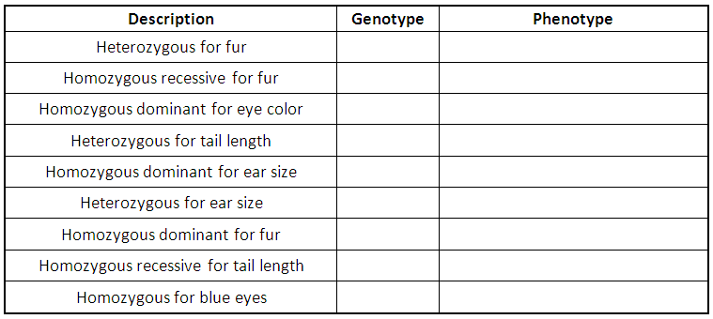

**Complete the following Punnett squares and answer the questions go with each pair.**

**Use the table of information below to answer questions 1-4.**

1. **Gg (**♂**) x Gg (**♀**)**

What is the ratio of green feathers to yellow feathers?

_______________________

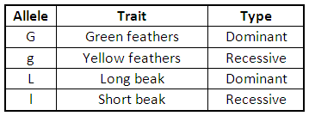

4. **Ll (**♂**) x Ll (**♀**)**

What percentage of offspring

will have long beaks?

_______________________

2. **GG (**♂**) x Gg (**♀**)**

What percentage of offspring will be

homozygous recessive?

_______________________

3. **A male which has a short beak is crossed with a female that is heterozygous for beak length.** What percentage of offspring will have short

beaks?

_______________________

6. **pp (**♂**) x Pp (**♀**)**

What percentage of offspring

will have white flowers?

_______________________

**Use this information for questions 5-9 on this page.**

5. **Ss (**♂**) x ss (**♀**)**

What will be the ratio of smooth peas to wrinkled peas?

_______________________



7. **A plant which is short is crossed with a plant that is homozygous dominant for height.** What percentage of plants will be short?

_______________________

9. **A plant which is homozygous for purple flowers is crossed with a plant that has white flowers.** What percentage of offspring will

have purple flowers?

_______________________

8. **Two plants which are heterozygous for pea shape are crossed with each other.** What percentage of plants will have

wrinkled peas?

_______________________

© Haney Science